**LETSUPGRADE LINUX ADMINISTRATION**

**DAY 6 ASSIGNMENT**

1. **Use ps to search for the “systemd” process by name.**

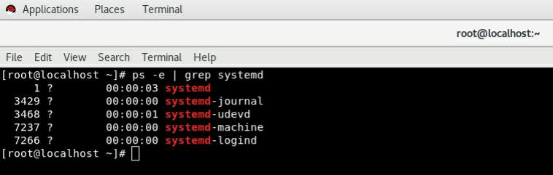

1. **Find out your terminal name. Using your terminal name, use ps to find all processes associated**

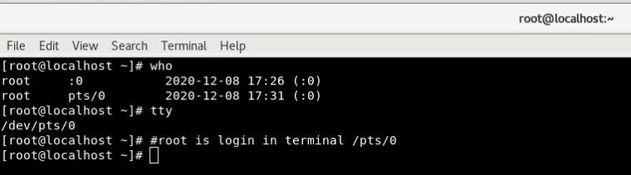**#/pts/0 is login terminal for root here**

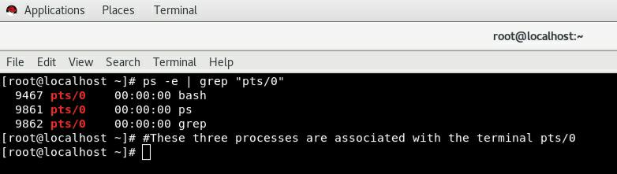

1. **Check and note the process id of your shell (from the output of the above command).**

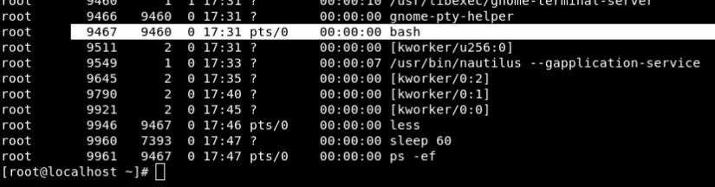**Parent PID Is 9467 and ProcessID Is 9460**

1. **Start 3 instances of “sleep 123” as background processes.**

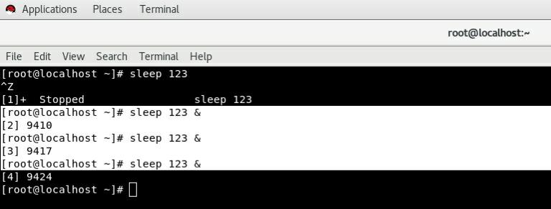

1. **Check and note the process id’s of all sleep processes.**

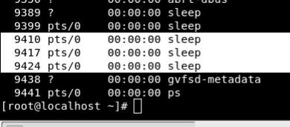

1. **Display only those three sleep processes in top. Then quit top.**

